Tableau Homework - Citi Bike Analytics

Data Source
CSV file 2013-11-citibike-tripdata.

Visualizations
https://public.tableau.com/app/profile/miniy/viz/HW_16365922422570/Dashboard2?publish=yes

Analysis
The file contains analysis of
- Popular Start Location – Map
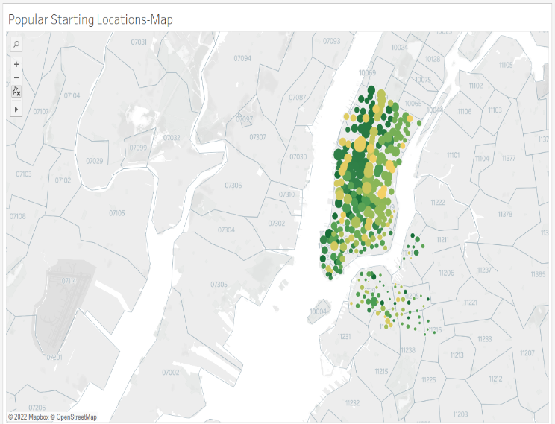

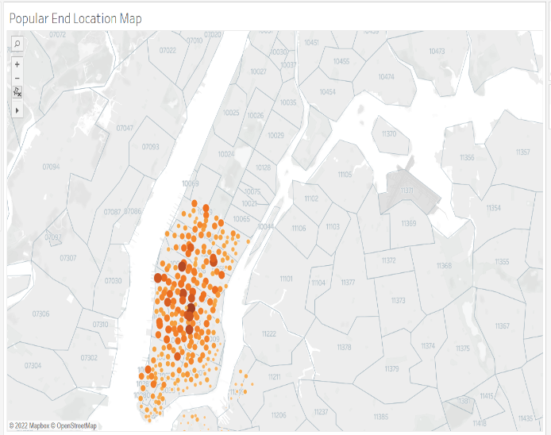
- Popular End location -Map

- Top 5 used bikes
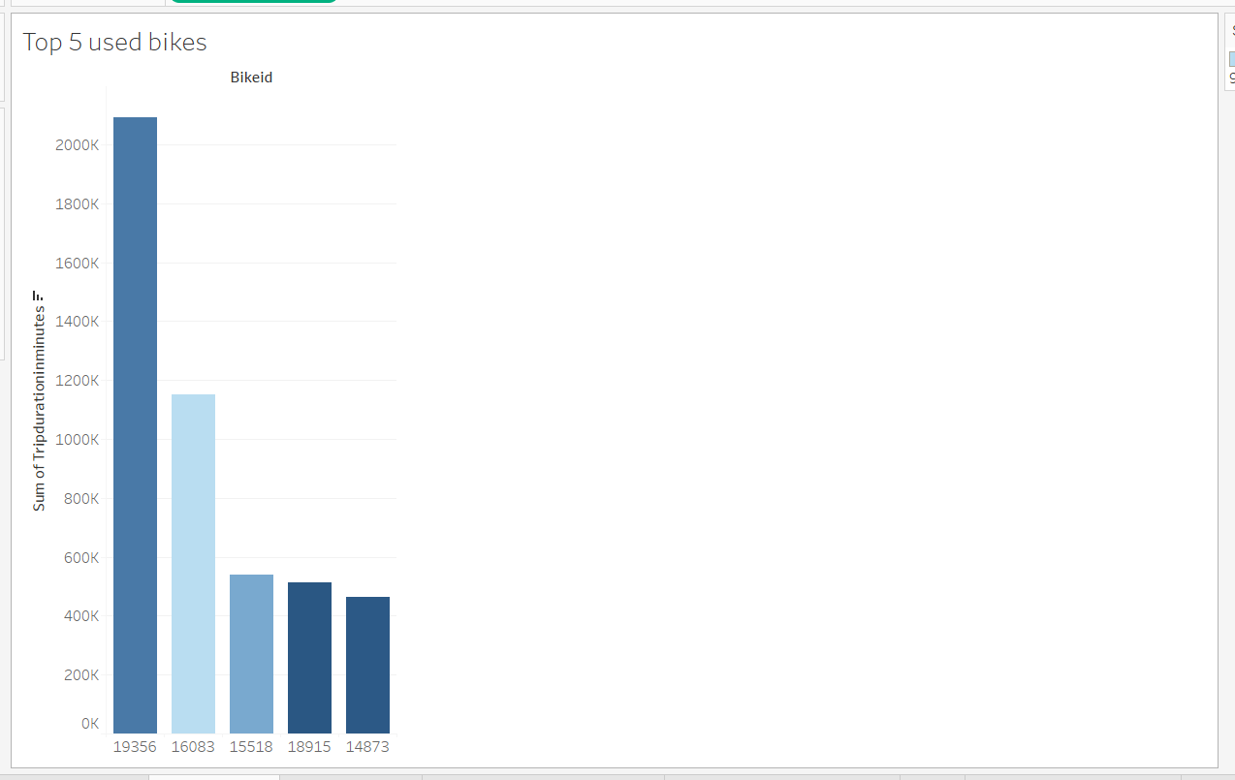
- Popular start time
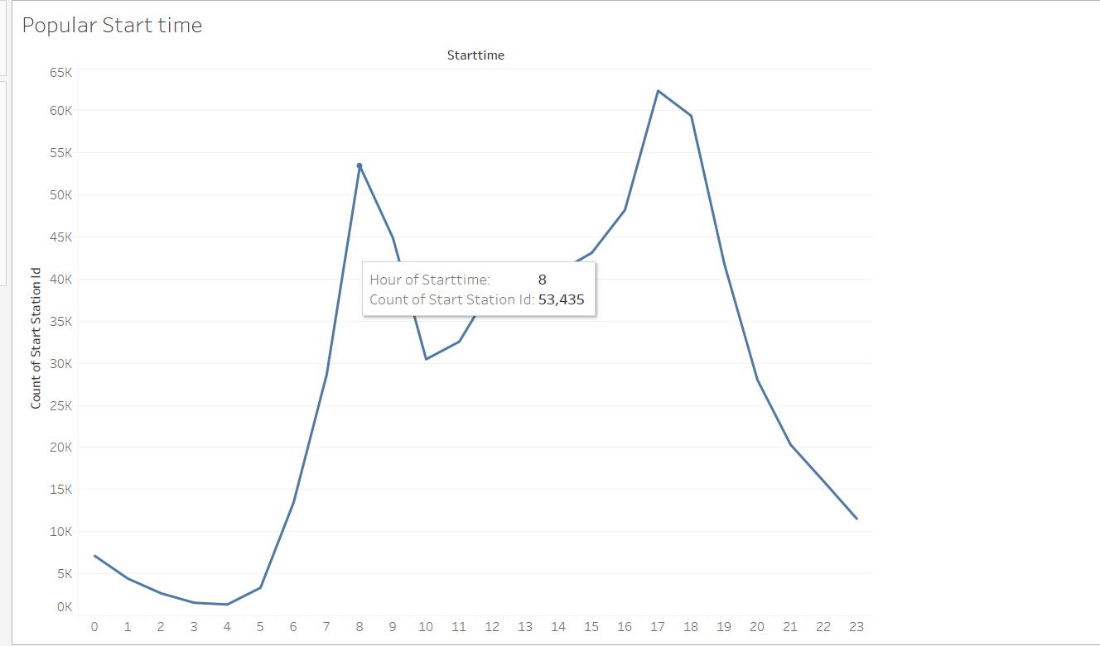
- Top stations for starting a journey
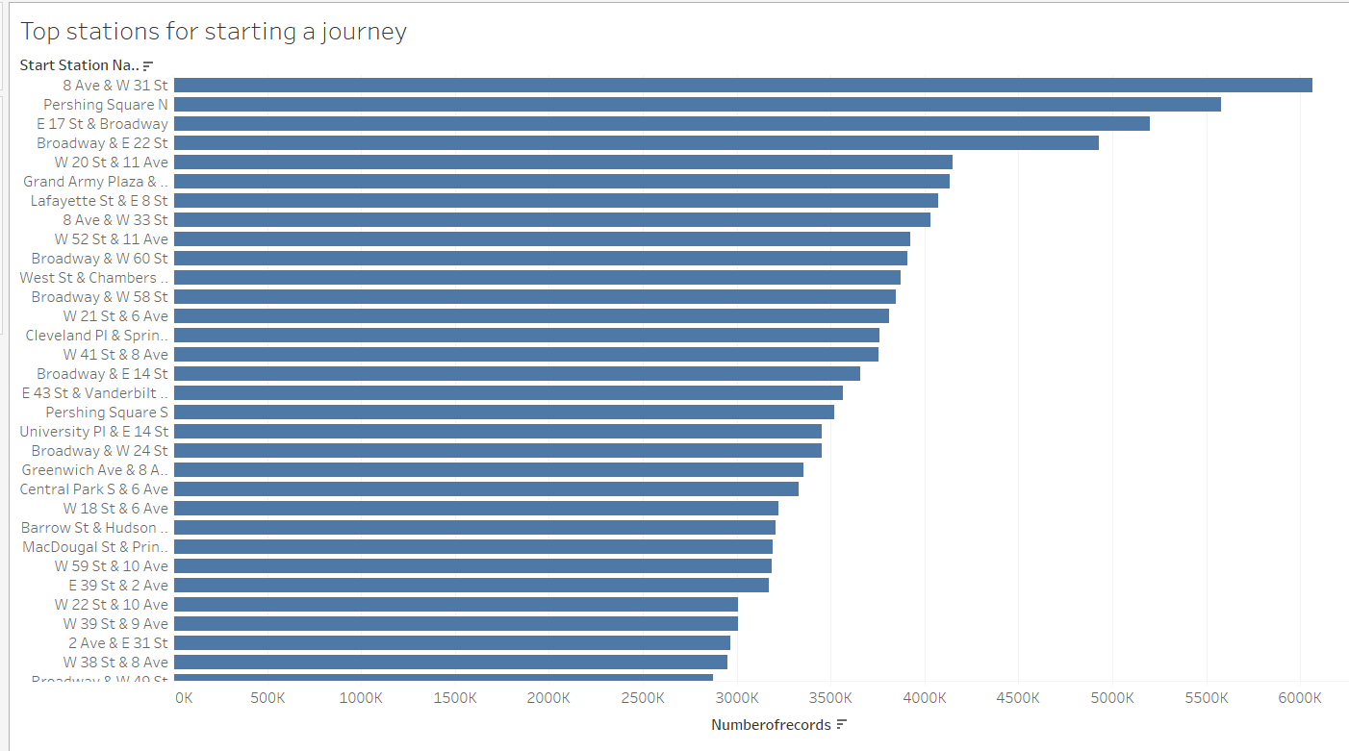

- Top stations for ending a journey
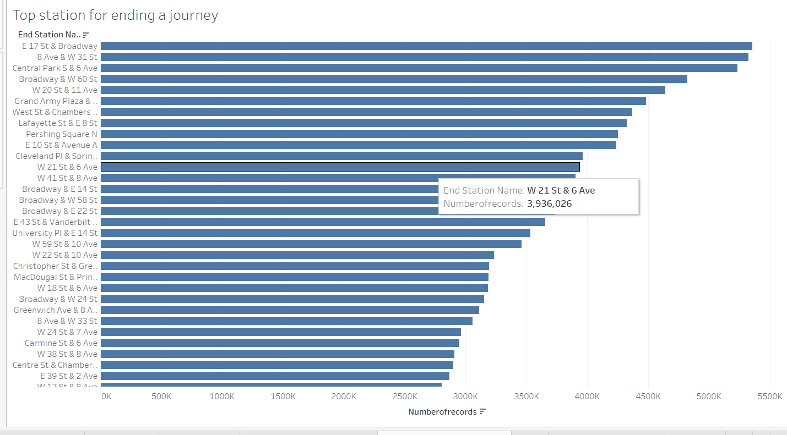

- Gender
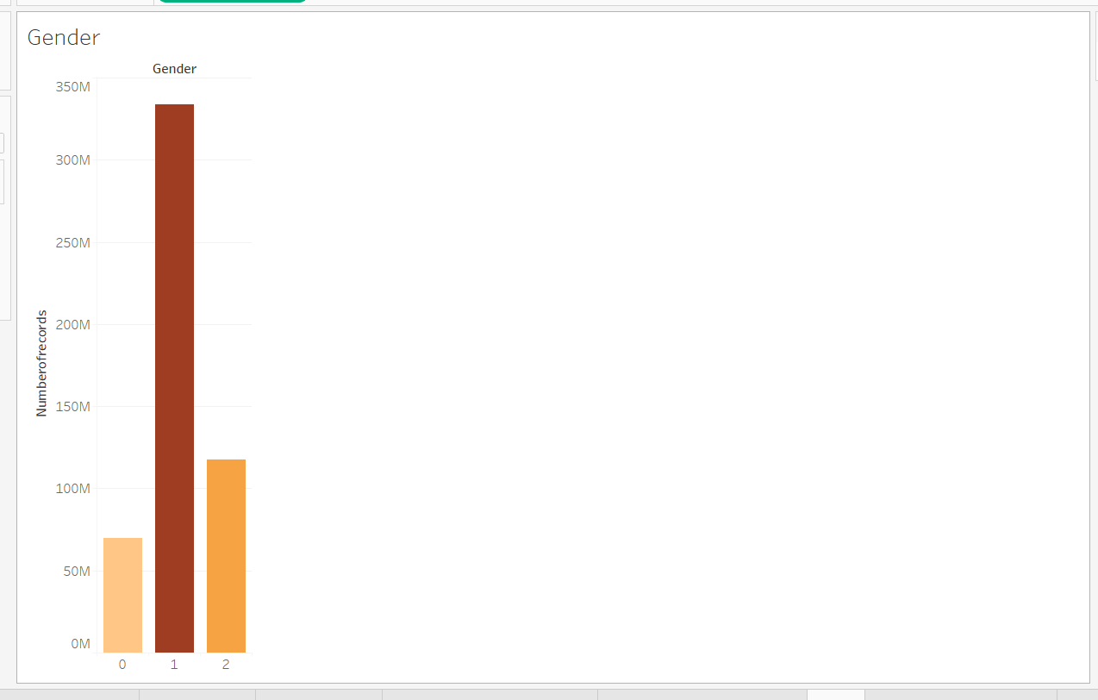
- Average Trip Duration by age
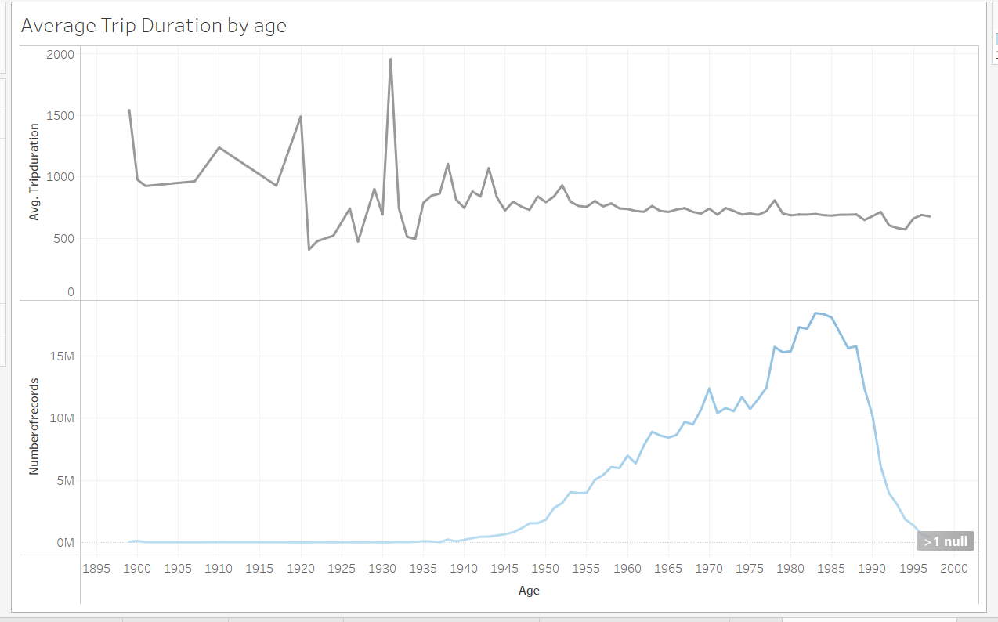
- Users by Age
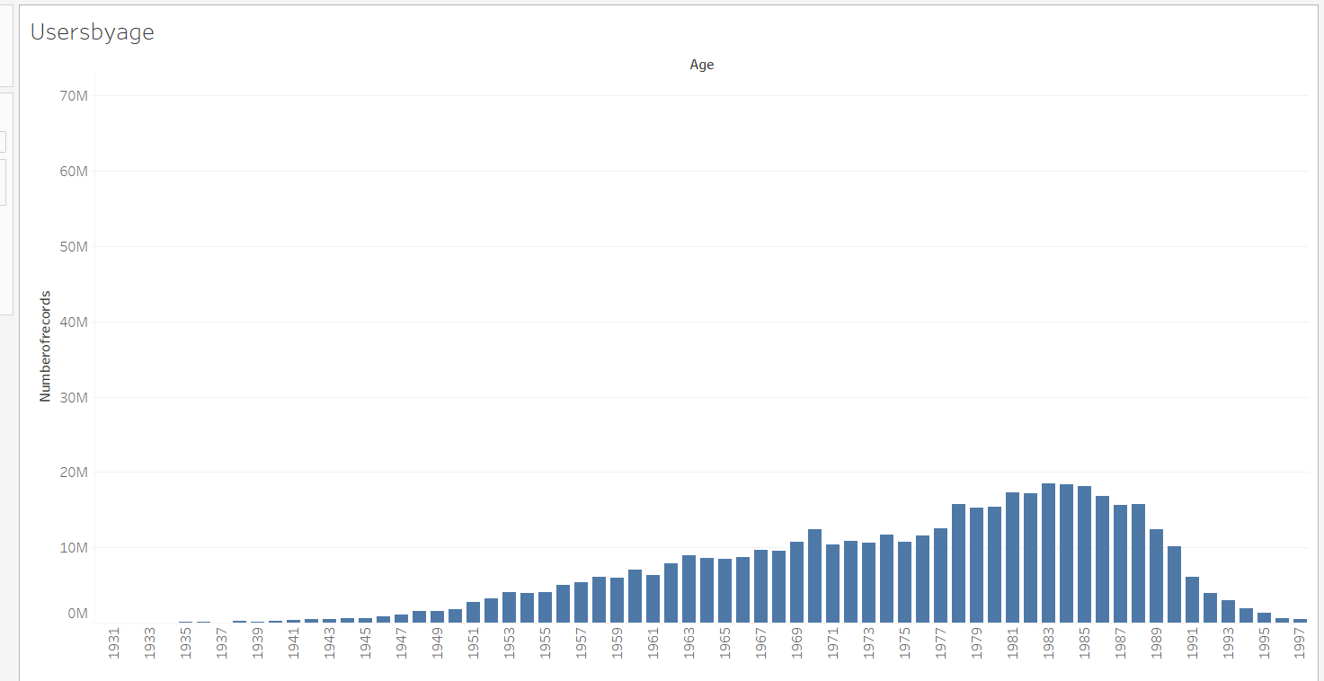
- Variability by bikeid
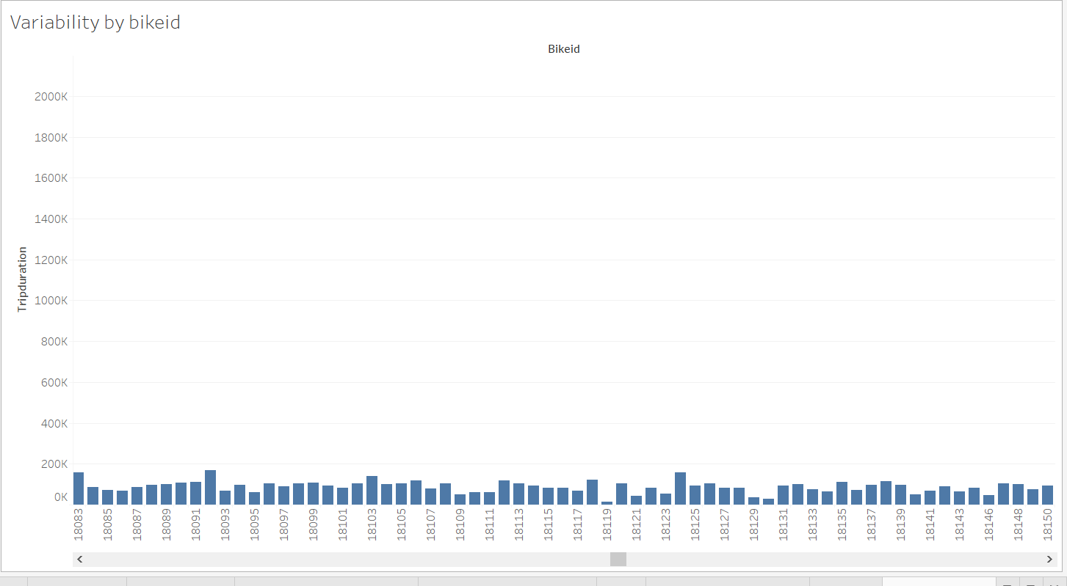

Dashboard1
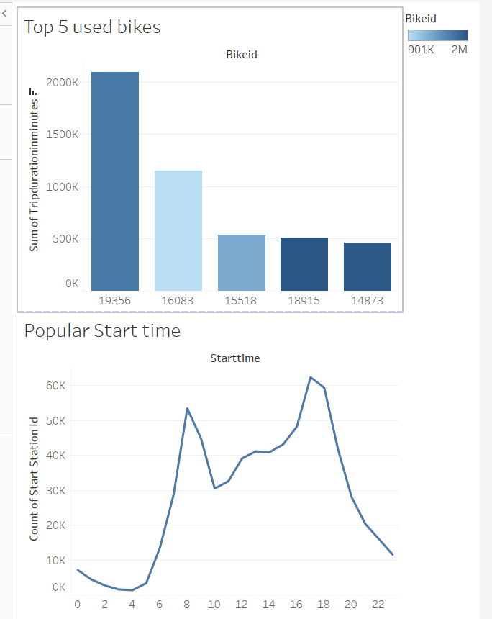

Dashboard 2
